الجمهورية اللبنانية
وزارة التربية والتعليم العالي الإمتحانات الرسمية لشهادة الإمتياز الفني
المديرية العامة للتعليم المهني والتقني لدورة عام 2015 الأولى
=========
الاسم والشهرة:--------------------

رقم المرشح :----------------------
الإختصاص والرمز : المعلوماتية الإدارية (23107) - (24008)
المادة : طرائق التحليل المعدل : (12)
المستندات المسموح بها : لا شيء المدة : ثلاث ساعات

Treat the following questions:

Question 1: Transform the following CDM to LDM: (5 pts)

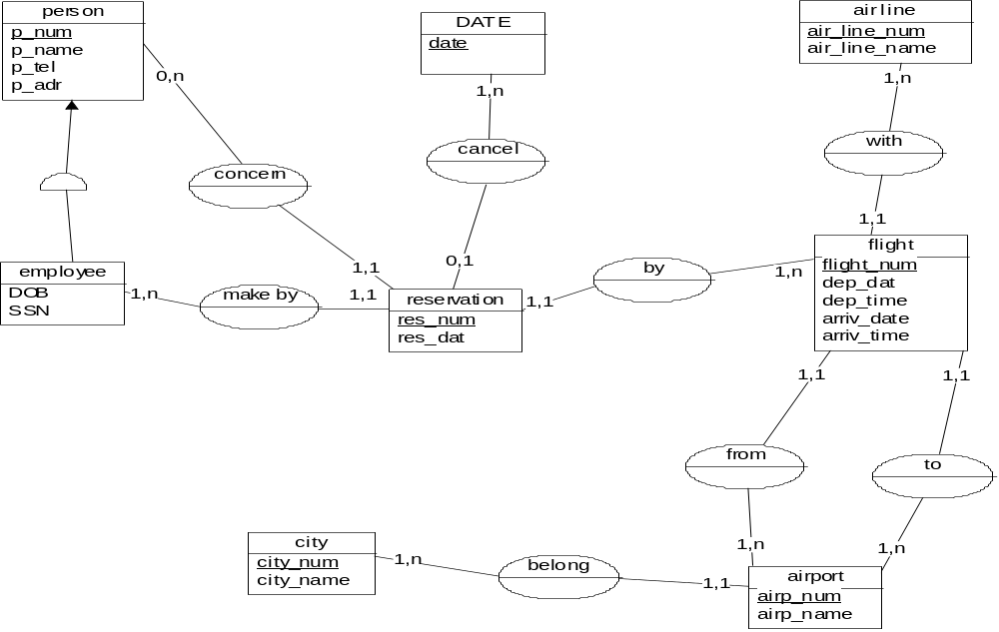

Case study1: rental of equipment
It is an information system of a company that rents equipment to its customers.
Rentals are in the various agencies of the company.
Interviews have been detected the following management rules:
R l: all rentals have a duration expressed in number of weeks and at least a week.
R2: A rent concerns 1 or several materials.
R3: All rentals must lead to a contract between the company and the customer.

The interviews have also enabled the collection of the following documents:
Clients list

CODE NAME STREET CITY TEL
000 1 SAMI HAMRA BEIRUT 01-444560
000 2 DANI SAMI SOLEH BADARO 01-237854
000 3 FOUAD SYRIE TRIPOLI 06-250876

LIST OF AGENCIES

N° AGENCIE

01 Beirut
02 Tripoli
03 Saida

الإختصاص والرمز : المعلوماتية الإدارية (23107) - (24008)
المادة : طرائق التحليل المعدل : (12)
المستندات المسموح بها : لا شيء المدة : ثلاث ساعات

CATALOGUE:

REF DESIGNATION RENT PRICE/WEEK
X01 AMPLI 200
X02 MAGNETOSCOPE 300
X03 TELE 150
X04 SPEAKER 50
X05 LASER DISK 200

STATE OF AVAILABLE STOCK:

AGENCIE 01

REF AVAILABLE QUANTITY
X01 20
X02 40
X03 40
X04 50
X05 10

AGENCIE 02

REFAVAILABLE QUANTITY
X01 40
X04 80

~X04

CURRENTS CONTRACTS:
Contract N° 300 Agencie01
Date: 15/02/2015client: 0001 SAMI
Duration: 4 weeks amount: 1800

REFdesignation rental quantity
X03TELE 1
X02 Magnetoscope 1

Contract N° 301 Agencie02
Date:16/02/2015 client: 0002 DANI

Duration: 2 weeks amount: 600

REFdesignation rental quantity
X01AMPLI 1
X04 SPEAKER 2

Contract N° 302 Agencie02
Date: 16/02/2015 client: 0001 SAMI

Duration: 2 weeks amount: 300

REFdesignation rental quantity
X03TELE 1

الإختصاص والرمز : المعلوماتية الإدارية (23107) - (24008)
المادة : طرائق التحليل

1. Establish the data dictionary. (Specifying the names of the attributes, their types and any constraints). (2 pts)
2. Build the conceptual data model (MCD). (Illustrating entities with their identifiers and their properties and the relations with the cardinalities). (7 pts)

Case of Study 2: driving permits
The examiner sends to the conduct permission service department a notice of successful completion of the permit review, it shall issue to the candidate a probationary permit.

If, after 2 years, the new driver has not committed any offence, the permission service sends a permit confirmed with a point at its maximum capital (to fix ideas, 100 points).

If, during the probationary period, the driver reported an offence, his permit was withdrawn (provisional withdrawal which forced him to take an examination within a period of six months).

Past the probationary period, the offences identified by the gendarmerie or the police start the capital of driver's points.

The offences are subject to a scale: 80 types of offences are listed with a variable penalty 4 to 25 points, depending on the severity. When the capital of point's falls to 20 or below, the license is withdrawn; it is the same for a single infringement which its value is 14 points or more.

The withdrawal of points is signified to the driver by a warning.

If the driver passes a period of 2 years without offence, his removed points are cancelled and its maximum capital restarts from 100 points.

In the event of serious offences recorded by police or gendarmes (driving in state of drunkenness, hit-and-run driving...), driving licenses can be removed permanently by a court, without any effect of the point system.

The final withdrawal procedure is also applicable during the probationary period.

1. Draw the diagram of flows and the actors. (2 pts)
2. Draw the conceptual model of treatments (TCM). (4 pts)

